**Lab Exercise for EEEE–380 SPICE Introduction Lab**

**(9/20–9/21/2017)**

Do schematic capture to create this simple circuit (this bitmap is from LTspice):

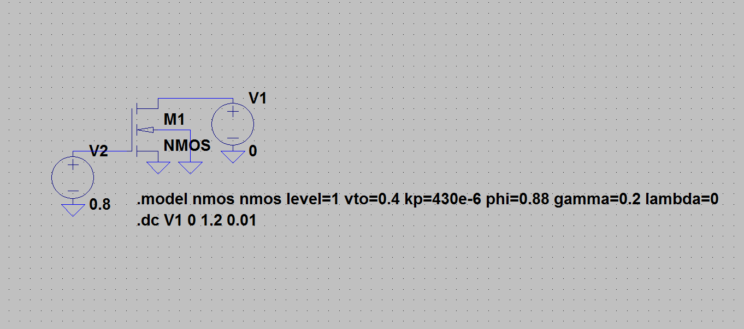

**Component selection:**

For the MOSFET, choose **nmos** from the component pull-down listing (**nmos4** automatically connects body to source, which is OK here, but not in the future when there are stacked NMOS devices). Use Escape after placing one instance; otherwise, another instance will be placed everytime you click.

For the voltage sources, choose **voltage** from the component pull-down listing.

**Ground** has its own button.

Use the **wire** button to connect the components as shown.

**Modifying the components:**

Right-click on one of the voltage sources and enter the default voltage value. Repeat for the other voltage source.

Right-click on the MOSFET and enter the length (0.1 μm) and width (1 μm) as 0.1u and 1u, respectively.

**Creating the operating statements:**

Click the **.op** button on the far right top and enter the following (as seen in the bitmap above):

.model nmos nmos level=1 vto=0.4 kp=430u phi=0.88 gamma=0.2 lambda=0

Hit OK, then click to place the **.model** statement somewhere in the schematic field of view, as above.

The DC sweep can be entered in the same way. Alternatively, under the **Simulate** pull-down menu, choose **Edit Simulation Cmd**. Choose a DC sweep, then indicate the source that will be swept. Use the name of the one that corresponds to *VDS* of the MOSFET, not the one driving the gate. Choose a **Linear** sweep, and sweep from 0 to 1.2 V in 0.01 V increments. Hit OK, then click to place the **.dc** statement somewhere in the schematic field of view, as above.

**Running the simulation:**

Click the **Run** button at the top (or pull down the **Simulate** menu and choose **Run**. An empty graph will appear (unless you’ve had the foresight to tell the program what you want plotted). Click the **Pick Visible Traces** button at the top (or pull down the **View** menu to **Visible Traces**) and choose the drain current associated with the MOSFET (**Id(M1)**) and hit OK. The trace should automatically appear in the graph.

**Sanity Check:**

If you did everything correctly, the saturation current should be 344 μA, and *VDSsat* should be 0.4 V, as shown below:

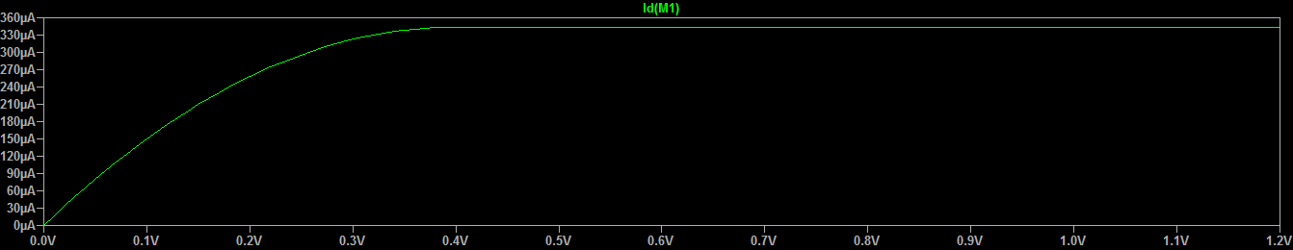

**Playing Around:**

You can easily edit an operating statement by right-clicking it. Change the SPICE model level to level 2 and re-run the simulation (just hit the Run button again) and observe the effect on your I-V curve. You should see less current and a lower *VDSsat*.